**Week 2- Lab Session**

**Practice with if-else Statements and Loops in Python**

**Objective:**

Students will analyse and modify Python programs using if-else statements and loops, explain how these structures control program flow, and present their findings to demonstrate understanding.

**Instructions:**

1. **Scenarios:**
   * You will be given a Python code snippet using if-else statements and loops.
   * Identify what the if condition is checking and how it affects the program.
2. **Modify the Code:**
   * Change the conditions or loop behavior to see how the output changes.
   * Test different inputs to observe how the logic works.
3. **Prepare Your Explanation for each Scenario:**
   * What does the if statement do in this code?
   * How does the loop work in this context?
   * What happens if you change a condition?
4. **Submit your answers along with screenshots of your execution:**

**Scenarios: (submit at least 5 of them)**

**Scenario 1: Checking Even and Odd Numbers**

**Task:** Modify the code to also check if the number is **divisible by 5** and print a different message.

**Scenario 2: Grading System**

**Task:** Modify the code to handle **edge cases** (e.g., negative scores or scores above 100).

**Scenario 3: Password Authentication (Loop Example)**

**Task:** Modify the code to allow the user to **reset the password** after three failed attempts.

**Scenario 4: Age Verification**

**Tasks:**

1. Modify the code to check if the age is a **negative number** and display an error message.
2. Add another condition to classify users as **senior citizens (65+)**.

**Scenario 5: Temperature Check**

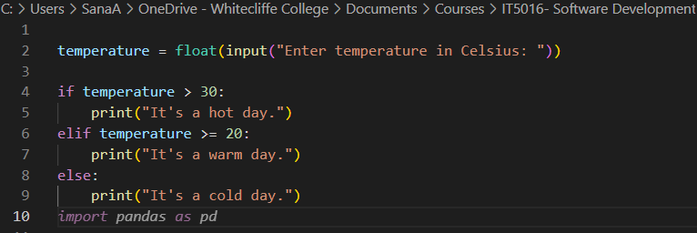

**Tasks:**

1. Modify the program to convert the temperature from **Fahrenheit to Celsius** before applying conditions.
2. Add a condition to check if the input is **too extreme (e.g., above 50°C or below -30°C)**.

**Scenario 6: Login System (With Limited Attempts)**

**Tasks:**

1. Modify the code to **lock the user out for 10 seconds** after 3 failed attempts.
2. Allow the user to reset the password if they fail three times.

**Scenario 7: Even or Odd Number Checker**

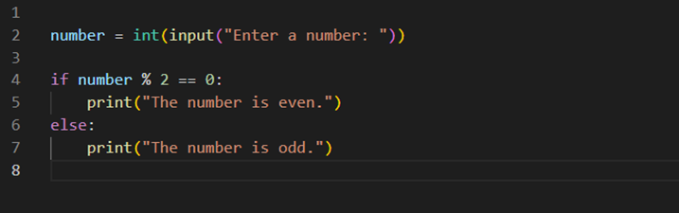

**Tasks:**

1. Modify the program to check if the number is **both even and divisible by 5**.
2. Add validation to ensure the user **only enters a positive number**.

**Scenario 8: ATM Withdrawal System**

**Tasks:**

1. Add a **PIN verification** before allowing withdrawals.
2. Restrict withdrawals to **multiples of 10** only.

**Scenario 9 : Grading System**

**Tasks:**

1. M️odify the code to **handle edge cases** (negative scores or scores above 100).
2. Add **feedback messages** for each grade (e.g., “Excellent” for Grade A).